Performance Testing

Date | 06 November 2025
Team ID | F529277D47452DB9E7447BD087E08E5E
Project name | Medical inventory management
Maximum marks | 4 marks

Goals & high-level objectives :

Verify system can handle expected and peak loads for core flows (search, read inventory, place/confirm orders, add/update stock, bulk imports).

Validate response-time SLAs, throughput, and resource usage under load.

Confirm data integrity and concurrency safety during high contention (e.g., two users decrement same stock).

Find bottlenecks (DB, API, caches) and gather actionable metrics for tuning and capacity planning.

Authentication / token refresh — visible at session star

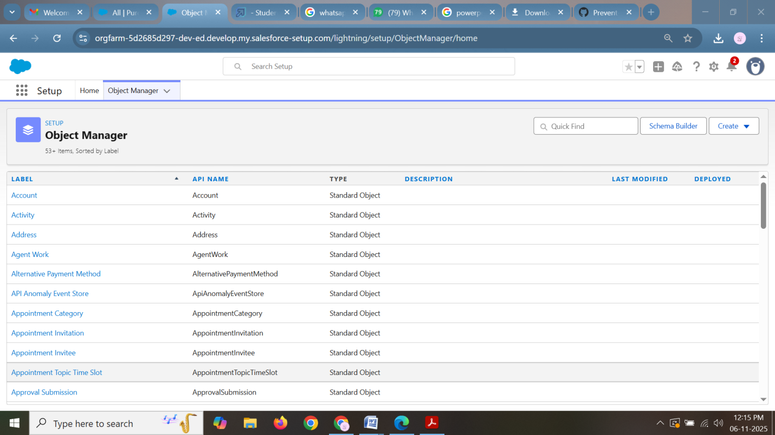

Performance metrics & SLAs (example):

Inventory read (GET): 99% ≤ 500 ms, 99.9% ≤ 1.5 s

Inventory search (list) paginated: 95% ≤ 1.0 s, 99% ≤ 2.0 s

Place order (write flow): 95% ≤ 2.0 s, 99% ≤ 4.0 s

Bulk import: completes within X minutes depending on size (e.g., 10k rows < 5 min) — measure per-case

Error rate: ≤ 0.1% under normal load

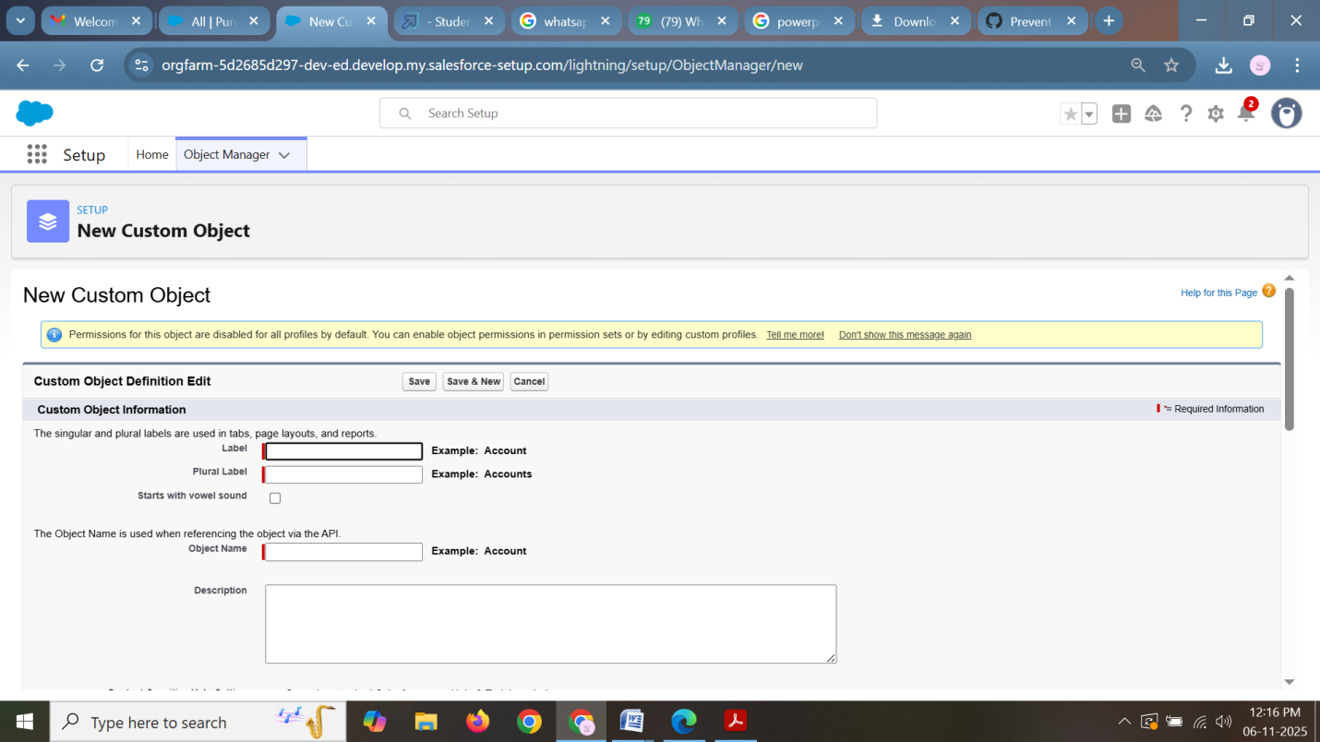Test scenarios & user journeys (with mixes):

Read-heavy scenario (70% reads, 20% searches, 10% writes) — representative of normal operations.

Write-heavy scenario (50% writes — orders/stock updates, 30% reads, 20% searches) — simulate stock reconciliation or inventory audit day.

Concurrency contention: many users attempt to decrement same SKU concurrently (simulate limited stock) — test optimistic/pessimistic locking.

Bulk upload scenario: run import job while system under normal load (observe effect).

Failover/ degraded mode: take one app node down mid-test, verify graceful degradation and performance of remaining nodes.

Long-run endurance: sustained peak for 6–8 hours.

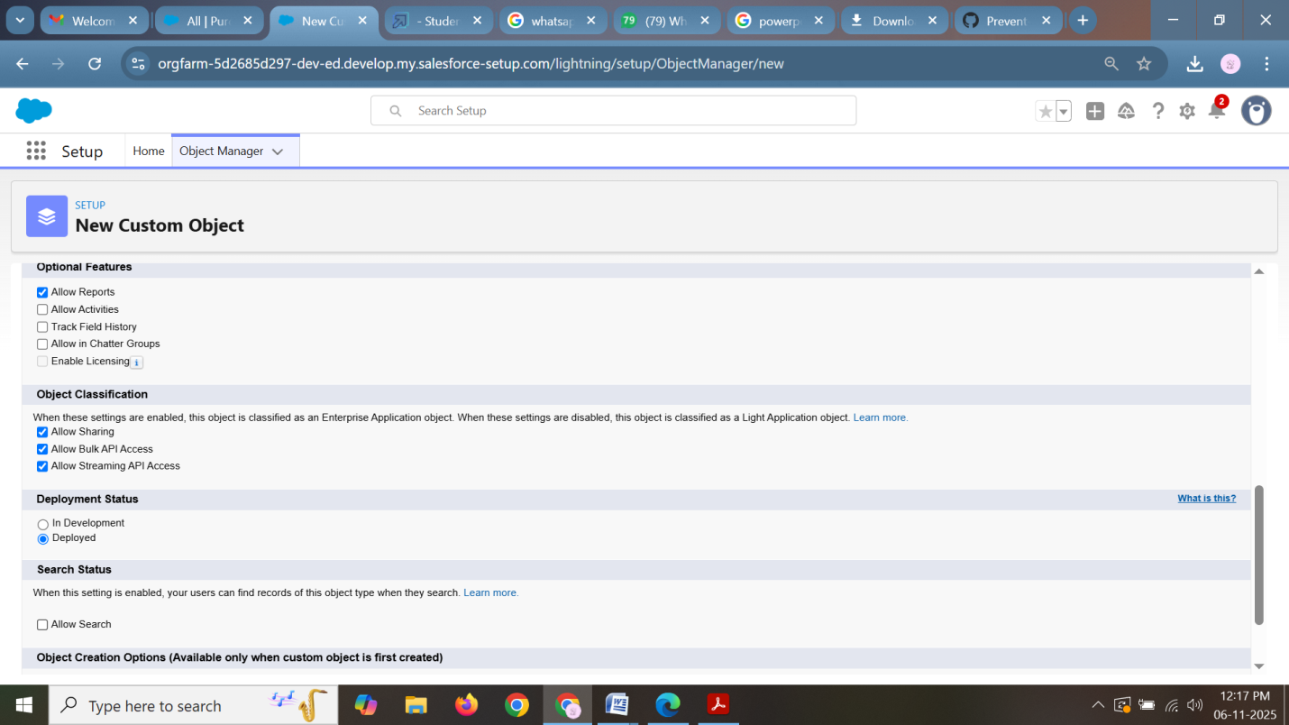

Test data & state management:

Use a dedicated test environment with production-like dataset sizes (number of SKUs, categories, orders).

Prepare multiple user accounts with roles and tokens; reuse session cookies to simulate session behavior.

Include realistic SKU distributions: many low-activity SKUs + a smaller set of "hot" SKUs that get frequent reads/updates.

Data seeding scripts: create N SKUs (e.g., 100k), M locations (warehouses), and historic orders to produce realistic DB sizes.

Reset/rollback strategy between runs (DB snapshots, container reset, or test DB clones).

